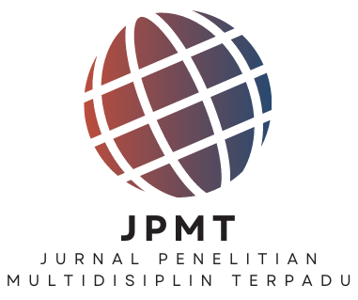

LETTER OF ACCEPTANCE
FOR SCIENTIFIC ARTICLES PUBLICATION
No. 30/JPMT/LoA/1-X /2026

Chief of Editor Jurnal Penelitian Multidisiplin Terpadu (JPMT) has decided that the name article below has been accepted on JPMT and will be published in Vol 10 No 1 2026.

Author | : Muhammad Arifin¹, Satma Nur Fitri², Nabillah Amanda Meizuri³,  Nadiratunnisa⁴, Chanda Khairun Nisa⁵, Muhammad Alfi Nurdin⁶,  M. Arda⁷, Arbanik⁸
Email | : muhammadarifinmf@gmail.com¹, satmanurfitri@gmail.com²,  nabillaamanda324@gmail.com³, nadiratunnisa04@gmail.com⁴,  cndakhrns@gmail.com⁵, alfinurdin81@gmail.com⁶,  ardamuhammad40@gmail.com⁷, arbanik77@gmail.com⁸
Title | : PERAN PENDIDIKAN AGAMA ISLAM DAN BIMBINGAN KONSELING  DALAM MENGATASI PERMASALAHAN ADAB DAN MORAL SISWA DI  SDN 086 DESA TEBAT PATAH
Affiliation | : Institut Islam Ma'arif Jambi

Thank you for submitting your article to our journal. We wish you all possible success in the future.

Warm regards,
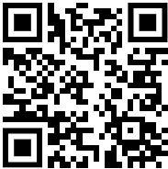

Jurnal Penelitian
Multidisiplin Terpadu
Chief Editor

